**HAMMAD MURTAZA**

**SID: 11146**

**CID: 107241**

**OS LAB 10**

Q1:

CODE:

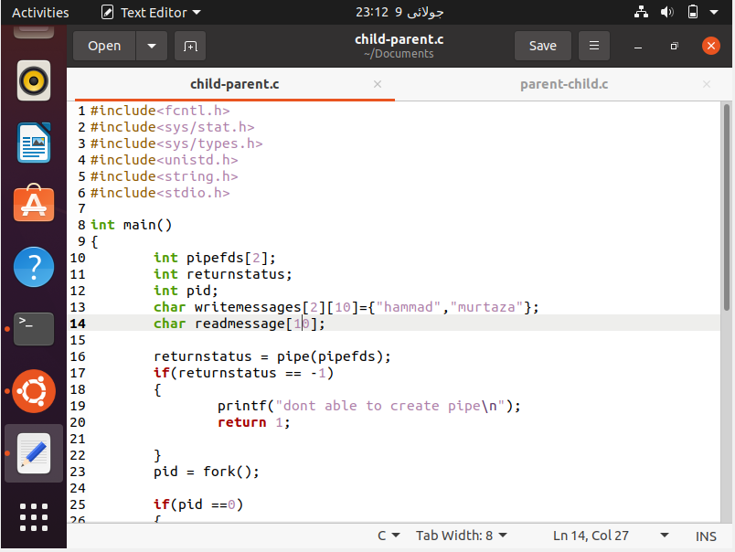

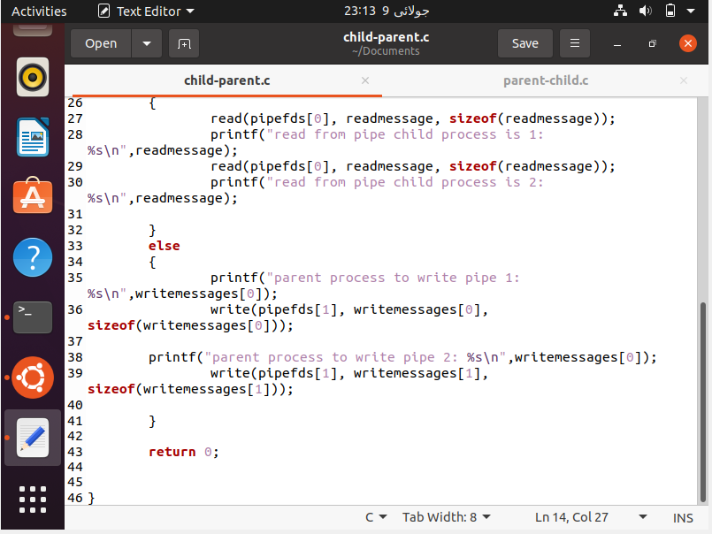

OUTPUT:

